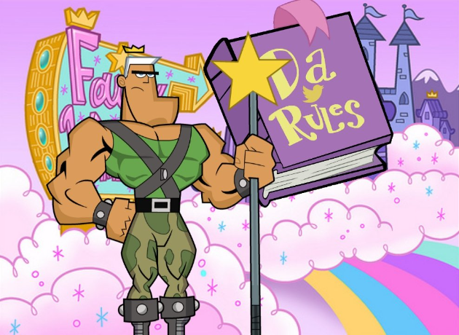

1. All Students must be in an EMT-B program at the time of signup. Former students are not allowed.
2. All students must sign their programs respective waiver. (Not applicable to our students).
3. All students must be in their programs respective uniform.
4. All students must be on the sign-up sheet for either IFT or Events. Students do not have direct access to the sign-up sheets.
5. Due to the number of schools requesting ride-outs, we do not offer shadow, volunteer or sponsor rotations.
6. Students are limited to one (1) IFT rotation. Students should be signed up at least two (2) weeks in advance.
7. Students who shadow for Stadium Medical are earning hours and previous experience, which will be taken into account when applying for employment.

